
IW-14
YEAR 7 SCIENCE
BIOLOGICAL SCIENCES
TEST 1 (MODIFIED)

NAME: CLASS: Mark: 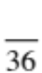

Achievement standards being tested
Interactions between organisms can be described in terms of food chains and food webs; human activity can affect these interactions.

Mark | ND | NW | C | HC | O
Mark Range | 0-10 | 11-17 | 18-22 | 23-26 | 27-36

Multiple Choice Write the answer to each question in the appropriate box at right.

1. Which of these human activities would have a negative impact on a natural environment?
QUESTION | ANSWER
1
2
3
4
5
6
7
8
9
10
11
12
13
14
15
16
17
i.e. Cause the number of plants or animals to decrease.

A Clearing forests and replacing them with exotic trees.
B Removing grazing cattle from a natural woodland.
C Replanting eucalypt trees.
D Reintroducing koalas into eucalypt forests.

2. A habitat is:

A a place where an organism lives.
B an ecosystem.
C a group of competitors.
D the way an organism behaves.

3. Which of the following is not an abiotic factor?

A Tree
B Water
C Light
D Temperature

4. Which of these human activities has a positive effect on food webs?
i.e. Cause the number of plants or animals to increase.

A Opening up an area of bushland for recreational activities.
B Removing introduced predators from an area.
C Overfishing particular fish species, causing a decline in numbers.
D Introducing exotic species, such as rabbits and foxes.

5. All animals are:

A producers.
B consumers.
C carnivores.
D decomposers.
6. Plants are examples of:

A producers.
B consumers.
C carnivores.
D decomposers.

7. In the food chain below, which organism is the third-order consumer?

grass  grasshopper  frog  snake

A Grass
B Grasshopper
C Frog
D Snake

8. Bacteria and fungi belong to an ecosystem group called:

A composers.
B decomposers.
C plants.
D herbivores.

9. The ultimate source of energy for all the organisms in a food web is:

A soil for providing essential minerals.
B water to prevent dehydration.
C green plants for photosynthesis.
D the Sun for providing light.

10. Which of the following are not decomposers?

A Fungi
B Mould
C Crustaceans
D Bacteria

11. The breakdown of dead organisms on and below the Earth’s surface is largely the responsibility of:

A consumers.
B decomposers.
C producers.
D scavengers.

12. Which of the following terms is best used to mean ‘close to extinction’?

A Rare
B Vulnerable
C Endangered
D Suspect

13. Identify the food chain that is part of this food web.

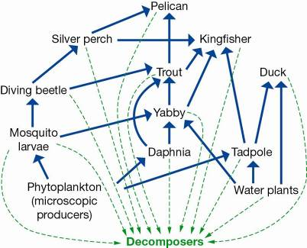

A Phytoplankton → daphnia → trout → duck → decomposers
B Water plant → tadpole → trout → kingfisher → decomposers
C Phytoplankton → mosquito larvae → yabby → silver perch → pelican → decomposers
D Water plant → yabby → trout → kingfisher → decomposers

Short Answer Write the answer to the questions in the spaces provided.

1. On the following pyramid, label each level using the following words:

carnivores, producers, herbivores.

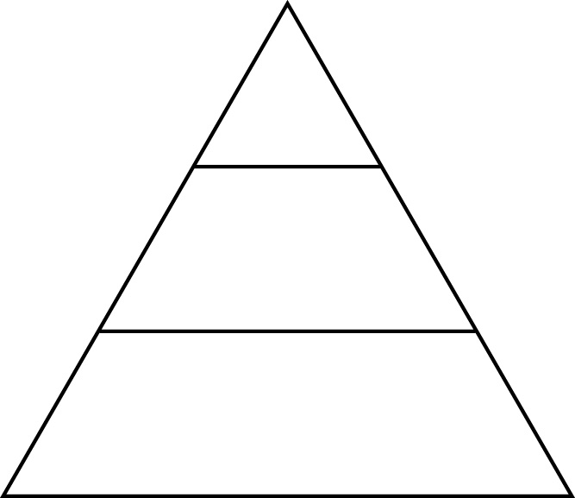
(3)
2. For each of the group of animals listed in the table, explain the type of food they eat.

GROUP | MEANING
Herbivore
Carnivore
Omnivore

(3)

3. Draw a simple food web involving the following organisms:
grass, worm, small bird, blue-tongue lizard, dingo.

(4)

4. The diagram represents a food web in a freshwater lake.

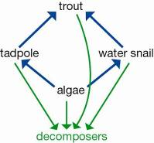

(a) What would be the effect on the number of water snails if very keen fishermen fished all of the trout out of the lake and they died out?

(1)

(b) Explain why this happens.

(1)

5. Describe these terms by matching them with the correct definition:

habitat, biosphere, ecosystem, environment.

(a) A particular area in which a group of organisms live, interacting with one another and with their non-living surroundings.

(b) The place where an animal or plant lives at a particular time.

(c) A combination of all of the living and non-living factors that an organism is subject to in the place where it lives.

(d) The place where all life exists. It consists of the Earth and its atmosphere.

(4)

6. The diagram below shows a small part of a forest food web. Name one organism that is a:

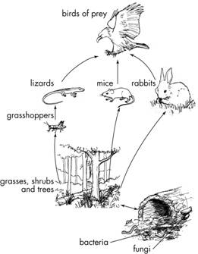
(a) first-order consumer.

(b) third-order consumer.

(c) producer.

(d) decomposer.

(4)

7. Study the diagram shown, which represents a food web in a freshwater creek.

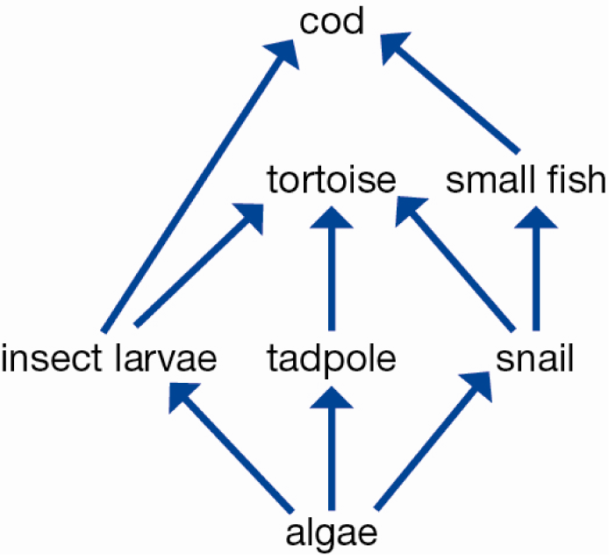

(a) Explain what the arrow between two organisms shows.

(1)

(b) Write down two different food chains that include the tortoise.

(2)

